Table of Contents

CHAPTER 1: Introduction……….….………………………………………………….1-2
1.2 Objectives 1
1.3 Scope 2
CHAPTER 2: System Design 3
CHAPTER 3: Application Features 6
CHAPTER 4: Technical Implementation 9
CHAPTER 5: Performance Optimization 13
CHAPTER 6: AI-Powered Anomaly Detection 14
CHAPTER 7: Testing and Quality Assurance…………..……………………………...16
CHAPTER 8: Deployment and Maintenance 19
CHAPTER 9: Conclusion and Future Scope 21
References 23
Acknowledgement………………………………………………………………………………….24

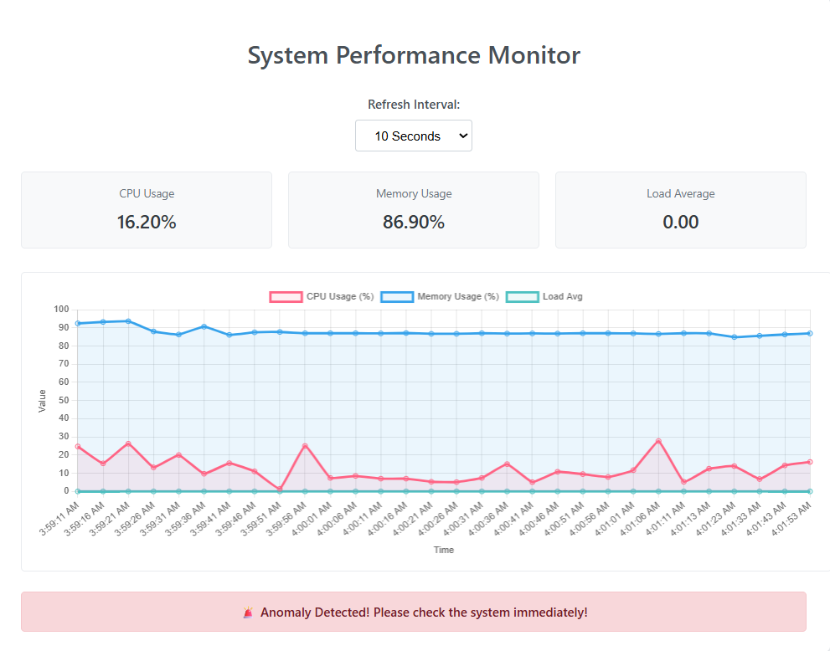
Figure. App Screenshot

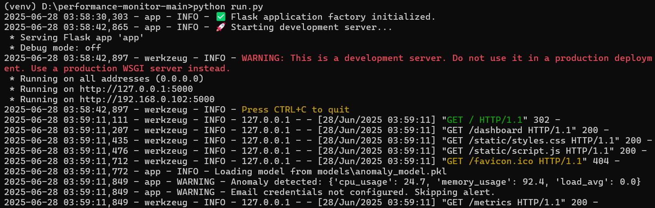
Figure. App Backend Screenshot
ABSTRACT

During my 5-month internship at BEL Smart City Division, I independently designed and developed a real-time Performance Monitoring System with AI-Powered Anomaly Detection to support infrastructure-level observability needs. This intelligent platform tracks key system metrics—including CPU usage, memory consumption, and load averages—and proactively identifies anomalies using a trained machine learning model.
The backend, built using the lightweight Flask web framework, exposes RESTful API endpoints and supports robust logging. The frontend uses HTML, CSS, and JavaScript with Chart.js to render real-time visualizations. The system is containerized using Docker and deployed on Render, enabling seamless, version-controlled deployments via Git.
A key innovation is the use of the Isolation Forest algorithm to detect abnormal patterns. Upon identifying a potential system failure or threshold breach, the system sends real-time email alerts to designated administrators, enabling proactive incident handling.
Developed from scratch within a production-facing smart city context, this modular and scalable solution demonstrates how AI and modern DevOps tools can be effectively integrated to build intelligent monitoring solutions tailored for critical infrastructure environments.

